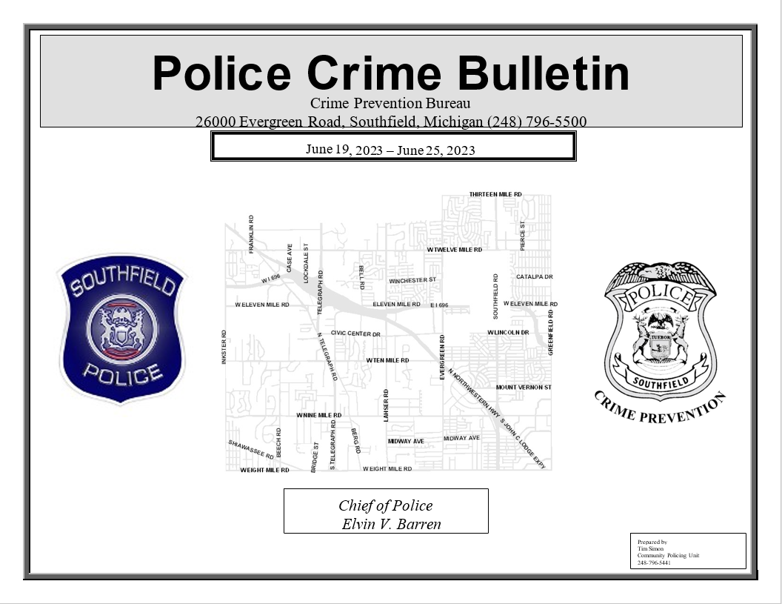
October 12th to October 18th, 2026
Automobile Thefts:
Date/Time |  |  | Address (block range) |  |  | Year, Make, Model | Details
10/17/2026 11:00 PM To: 10/18/2026 9:45 AM |  |  | 16000 W NINE MILE RD |  |  | 2026 DODGE DURANGO | The Victim reported that his vehicle was stolen overnight. No suspect information.
Tips:
- Never leave your vehicle running unattended
- Park in areas where your vehicle is viewable if possible
- Use commercially available security devices
Larceny:
Date/Time |  | Address (block range) |  |  | Item Taken |  | Details
10/12/2026 12:00 PM To: 10/14/2026 10:00 AM |  | 16000 CARRIAGE LAMP DR |  |  | Cash |  | The Victim reported that money was stolen from his home. No suspect information.
10/13/2026 12:50 PM To: 10/13/2026 3:02 PM |  | 16000 W NINE MILE RD |  |  | Golf Clubs and Bag |  | The Victim reported that his vehicle was entered and his golf bag and clubs were stolen. No suspect information.
10/13/2026 3:30 PM To: 10/13/2026 3:50 PM |  | 26000 TELEGRAPH RD |  |  | Groceries and clothing |  | The Victim reported that he was unpacking his belongings and left them at the door. The Victim walked away and return to find the items had been stolen. No suspect information.
10/13/2026 8:00 PM To: 10/14/2026 6:45 AM |  | 26000 BERG RD |  |  | Unknown what was taken |  | The Victim reported that her vehicle was entered and rummaged through but was unsure if anything was stolen. No suspect information.
10/13/2026 8:30 PM To: 10/14/2026 6:55 AM |  | 26000 BERG RD |  |  | Unknown what was taken |  | The Victim reported that her vehicle was entered and rummaged through but was unsure if anything was stolen. No suspect information.
10/14/2026 8:30 PM To: 10/15/2026 6:00 AM |  | 17000 LOUISE ST |  |  | Driver’s License and Debit Card |  | The Victim reported that his vehicle was entered and his license and debit card were stolen. No suspect information.
10/14/2026 10:00 PM To: 10/15/2026 6:45 AM |  | 16000 W NINE MILE RD |  |  | Shoes and Glasses |  | The Victim reported that his vehicle was entered and his shoes and glasses were stolen. No suspect information.
10/17/2026 11:06 AM |  | 27000 GREENFIELD RD |  |  | Three Bicycles |  | The Victim reported that three bicycles were stolen from her storage unit. No suspect information.
10/17/2026 11:00 PM To: 10/18/2026 12:00 AM |  | 24000 W TWELVE MILE RD |  |  | Wallet with cards |  | The Victim reported that his wallet was stolen while at the listed address. No suspect information.
10/18/2026 5:00 AM |  | 23000 LAHSER RD |  |  | Nothing taken |  | Southfield Police responded to a B/M attempting to enter vehicles. The suspect fled prior to Poice arriving. The suspect did not enter any of the vehicle and was described as wearing all black.
Tips:
- Ensure your vehicle is locked at all times and valuables are out of sight.
- Thieves wait for the right time and will move quickly
- Even if playing sports at a park ensure your vehicle is locked

Robbery:
Date/Time | Address (block range) |  | Item Taken |  | Details
N/A
Tips:
- Always be aware of your surroundings and report suspicious incidents or persons to your local police.
- If something doesn’t appear right or someone looks like they are up to no good, call the police immediately
- Trust your intuition
Weapons Offense:
10/12/2026 5:01 PM | 20000 KNOB WOODS DR |  | Handgun |  | Southfield Police responded to a male suspect shooting into the air during an argument. The suspect fled prior to Police arriving.
Tips:
- Always be aware of your surroundings and report suspicious incidents or persons to your local police

Breaking and Entering:
Date/Time | Address (block range) |  |  | Method | Description/Suspect Information
10/14/2026 1:31 PM | 19000 W EIGHT MILE RD |  |  | Broken Padlock | The Victim reported that her storage unit was broken into and items were stolen. No suspect information.
Tips:
- Do not display valuable items in windows when closed for business
- Contact the Southfield Police Crime Prevention Bureau for a free security inspection (248) 796-5409
Home Invasion:
Date/Time | Address (block range) |  |  | Method of Entry | Description/Suspect Information
10/18/2026 3:09 PM | 27000 BRADFORD LN |  |  | Attempting to force door | Southfield Officers were dispatched to a known suspect attempting to force his way into the home. The suspect attempted to flee in a vehicle but was stopped and arrested.
Tips:
- Let trusted neighbors know if you are not going to be at home
- Be cautious about who you let in your home for service and repairs
- Contact the Southfield Police Crime Prevention Bureau for a free home security inspection (248) 796-5409

